Motivation

Yelp is a website and mobile app that connects people with local businesses.

The Yelp community is made up of engaged locals who connect on-line and off-line to share

their opinions about local businesses. Millions of users connect on this application to,

rate and give reviews for businesses.

In this project, I have analyzed various factors to be considered for establishing a new restaurant

business in San Fransico area.

Data Collection

Using Web scrapping I have collected 990 restaurants information for San Fransico. I have collected Name, Cusine served, delivery availability for a restaurant, ratings & number of reviews for analysis.

Analysis

As we need to study the factors of top restaurants in SFO, I have considered restaurants with more than 1000+ reviews which is top 25% restaurants.

The different factors analyzed to start a new restaurant are:

Delivery: Can a restaurant with Delivery have any impact on reviews & ratings of a restaurant business.

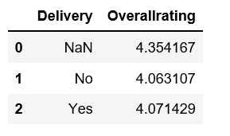

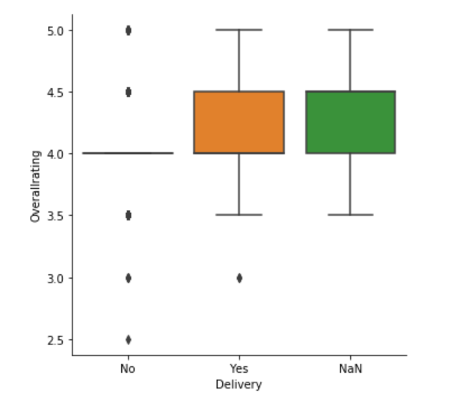

As per the above observations, Delivery doesn’t have impact on ratings of a restaurant.

Price: Does a restaurant with higher/lower price range have any difference in the ratings.

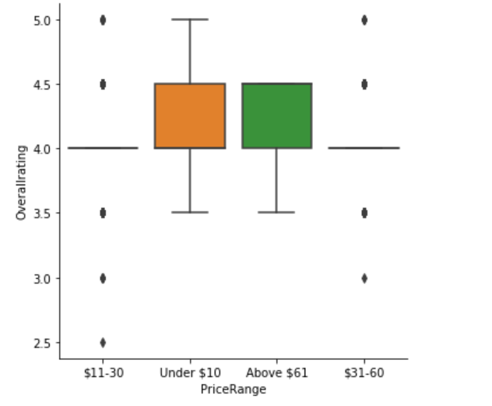

As per the above observations, Price range doesn’t have impact on ratings of a restaurant.

Cuisine: What are the top Cuisines to be considered for settingup a restaurant.

